EDF Power Solutions Burnfoot Hill Wind Farm Community Fund

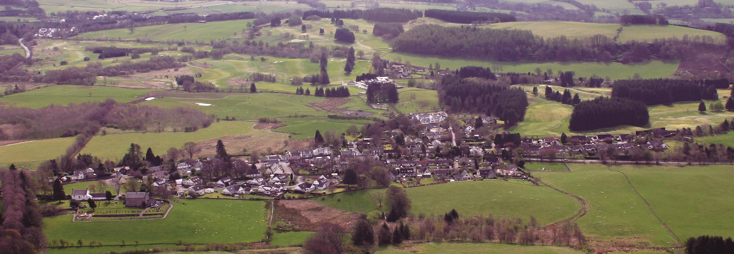

Muckhart Community Council

Microgrant Application Form 2026/27

- Contact Details

Name of group or individual applying:

Main contact:

Address:

Postcode:

E-mail: Telephone (main):

- About you or your organisation

- Are you a small, un-constituted group?

- Are you an individual?

- Are you a Constituted Group? Yes
*

- Details of Microgrant Requested

Tell us about you or your organisation (aims, purposes etc)

- Describe the activities that the microgrant will fund
- When will these activities take place?

- Tell us who and how many will benefit from the microgrant funding
- For each beneficiary identified what difference or change will the microgrant make

- How many volunteers are involved in delivering your project
- What are their roles?

What do you think the lasting changes the microgrant funding will make to you or the community
- How much are you requesting?

What will the micro-grant be used to pay for? (Please provide a cost breakdown and quotes where applicable)

Description | Cost
 | Total:

Declaration: I certify that the information contained in this application is correct and that I am authorised to make the application on behalf of the above group/ individual.

Name (please print):

Signature: Date:

Please send your completed applications to: ​sec.muckhartcc@gmail.com


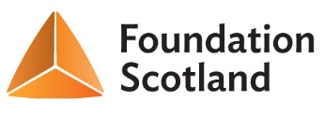
‘Funded by Foundation Scotland from the EDF Power Solutions Burnfoot Hill Community Fund’

