EDF Power Solutions Burnfoot Hill Wind Farm Community Fund

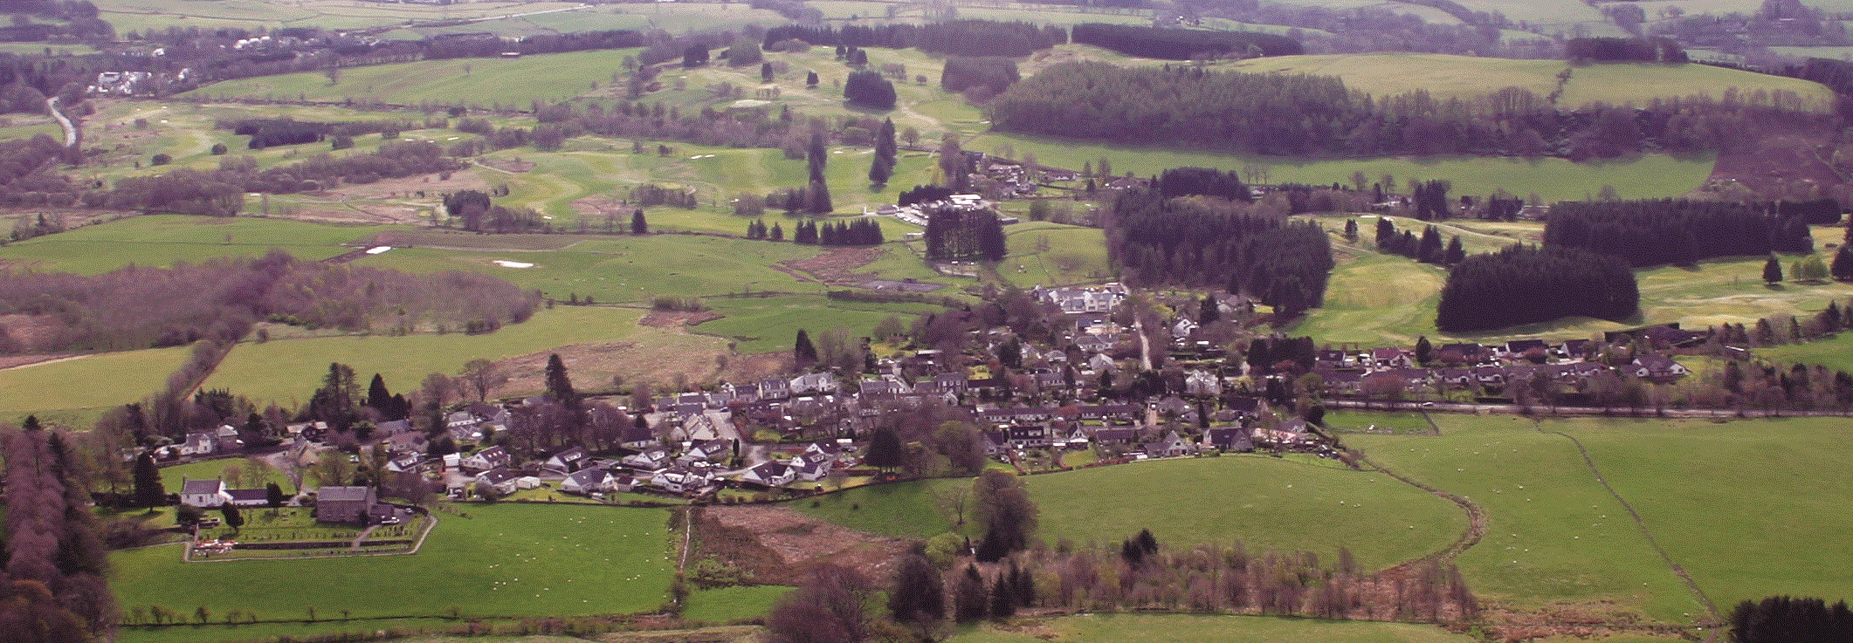

Muckhart Community Council

Event Fund Application Form 2026/27

- Contact Details

Name of group applying:

Main contact:

Address:

Postcode:

E-mail: Telephone:

- About your organisation

- Are you a small, un-constituted group?

- Are you a Constituted Group?

- Details of Event Fund Requested

Tell us about your organisation (aims, purposes etc)

- Describe the Community Event that the Event Fund will fund
- When will these activities take place?

- How will your Community Event bring the Community Together?

- Tell us who and how many will benefit from the funding

- How many volunteers are involved in delivering your project
- What are their roles?

What do you think the lasting changes Event funding will make the community
- How much are you requesting?

What will the micro-grant be used to pay for? (Please provide a cost breakdown and quotes where applicable)

Description | Cost
 | Total:

By signing the declaration below I confirm that:

- I have permission of the land owner, if required.
- I have or will have adequate insurance.
- I have carried out risk assessments and will have an appropriate event plan in place, if required.
- If required i will have appropriate licenses in place by the time of the event.
- I have reviewed Clackmannanshire Council’s guidance on running a public event Planning a public event (clacks.gov.uk)
Declaration: I certify that the information contained in this application is correct and that I am authorised to make the application on behalf of the above group/ individual.

Name (please print):

Signature: Date:

Please send your completed applications to: sec.muckhartcc@gmail.com

Thank you for your application.

Funded by Foundation Scotland from the EDF Power Solutions Burnfoot Hill Community Fund’





