Welcome to Muckhart

A Handbook to Knowing your Community

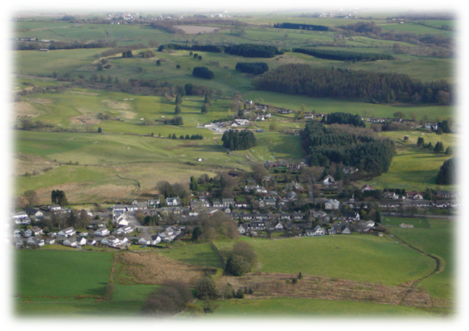

A warm welcome

We welcome you as a new resident and hope you will enjoy living in Muckhart and being part of our lively community. We hope that the information contained in this handbook will help you to settle into your new home and the community. The guide contains up-to-date and relevant information about the area. You will also find this and other information on our website at: www.muckhart.org.uk.

We hope you find this handbook useful and soon settle in. Please do get in touch if you have any additional suggestions you might have or if you find anything is wrong or missing – please contact sec.muckhartcc@gmail.com.

Contents

Page
- About us - Your Community Council 3
- MCC Newsletter 3
- About where we live 4
- Local community representatives 8
- Community activities and groups 9
- Getting about 16
- Household waste/recycling 17
- Local amenities 17
- Local services 18
- What’s on at the Coronation Hall 20
- Contact details 21
- Friends of Coronation Hall – 100 Club 23

About us – Our Community Council

Established by statute, Muckhart Community Council’s role is to act as the local voice for the community. It works in co-operation with Clackmannanshire Council and other public bodies and comments on planning and development issues as well as local issues which are of public interest. The Community Council meets 5 times a year in the Coronation Hall and has the AGM in September. Members are directly elected, and a list of the Community Councillors is shown below. All residents are invited to the Council meetings to meet their elected members and give their opinions and ask questions. Please do come along, you are most welcome. Council meetings are also attended by local Councillors and representatives of the Police. You can also sign up for a weekly newsletter by contacting sec.muckhartcc@gmail.com. Please see www.muckhart.org.uk for further information or the notice board outside the hall.

Your Community Councillors are:
Gillian Thompson – Chair
Matthew Pease – Vice Chair Jon Jordan
Danny Conroy – Treasurer Greig Ness
Marion Riddell – Secretary Celia Norton
Jonathan Bacon Neil Rodger

MCC Newsletter

As well as regular facebook posts and website updates, we produce an e-newsletter every two weeks, which includes a wide variety of information including events and activities, consultations, funding opportunities and lots more. If you would like to subscribe or have anything included in the newsletter, please send your email address to sec.muckhartcc@gmail.com.

About where we live

Muckhart consists of the conservation village of Pool of Muckhart and dispersed settlement of Yetts of Muckhart. The name of the parish was historically Mucard, and more recently Muckart or Muckhart. It is derived from the Gaelic words ‘Muc,’ a wild boar or pig, and ‘gart’ the head or ‘ard’ meaning high. Some suppose that his alludes to the shape of the hill terminating above the Yetts which from one point of view is supposed to resemble a pig’s head. Pool of Muckhart’s name originally derives from a small sheet of water which lay to the south of the present village.
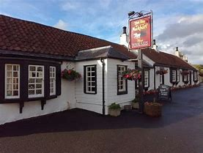
Muckhart is located at the eastern end of the ‘Hillfoot towns’ which skirt the southern edge of the Ochil Hills. The last in the range standing as a backdrop to the village to its north side is ‘Seamab’. Notably our front doorstep sits at the same altitude as the top of Stirling’s Wallace Monument
The village probably developed during the 18th century as a stopping place for drovers to water their cattle on the Glendevon drove road which connected the markets of Clackmannanshire, Perthshire & Fife
Previously Muckhart, together with Glendevon, formed the southernmost tip of Perthshire. It was transferred to Clackmannanshire in a reorganisation of boundaries in 1971. The parish boundary extends to the outer edge of Dollar. Due to local byelaws at the time, the village primary school is located in the centre of the parish, which is over half a mile west of the outer edge of the main village.
Muckhart includes several buildings of note including Muckhart Church, the Coronation Hall and the Muckhart Inn, an early 18th-century coaching inn. The main mansion house in the parish is Ballilisk, which lies north of the A91 between the two villages. In pre-Reformation times it served as a rectory to the adjacent chapel. It was birthplace and home of Bishop Paton in the 16th century. It was replaced by a new manse (to its west) around 1750 and was then sold. Rebuilt around 1800 it was home to the Izatt family for almost two centuries.
The war memorial, on the western edge of the village by the main road, is by local sculptor George Henry Paulin, son of Muckhart's then minister, Rev George Paulin.
In the churchyard is the family monument to the Christies of Cowden. This local estate was famed for its Japanese garden which was renovated in 2016 and is now Clackmannanshire’s main tourist attraction. Its original Japanese gardener is buried at the end of the Christie lair.
Information on key landmarks is given below.
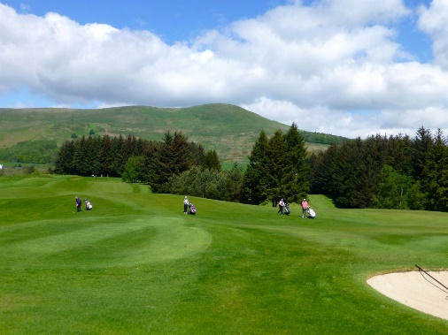
MUCKHART GOLF CLUB lies on Drumbum Road
south of the village. Set on a series of low rocky
hills it includes several challenging holes.

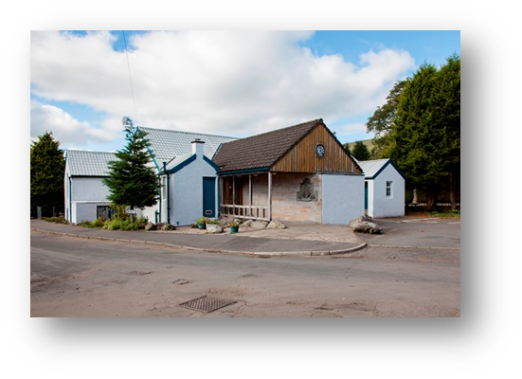

THE CORONATION HALL has been the been the hub of community life for nearly a century. The site for was donated to the village in 1929 by Ella Christie. The hall has been updated over the years and is warm, welcoming, cosy, charming and much loved. (Now has wi-fi access).

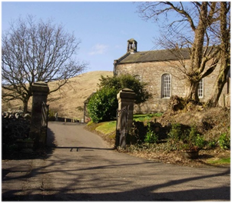
MUCKHART PARISH CHURCH is in a beautiful setting, sitting elevated from the village, on the left heading towards the Yetts. The parish boundary is somewhat unusual and extends to the outer edge of Dollar, some 3 miles west and follows the Devon River. The Church that stands today was built in 1838 and incorporates stone from a previous building dating back to 1560. The current congregation has around 80 members with ca. 35 plus regularly attending, including families with children. The Church has a flourishing Sunday School, and runs a Baby & Toddler Group, a Walking Group, a monthly Community Cafe, a Knitting and Nattering gathering, an Art Club and a Singing Group, details below.

In addition, there are other regular annual events, for full details please visit our website. The Church was fully renovated in 2014 and now offers a flexible, modern and comfortable accessible environment, in which regular activities are held.
www.muckhartparishchurch.com
https://facebook.com/muckhartparish.church.3
https://twitter.com/muckhartchurch
muckhartchurch@gmail.co
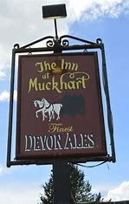 |  | THE MUCKART INN  Our family run village Inn has been owned by the Gibson family for over 25 years but has stood in the heart of the village for more than 200 years. Originally an 18th-century coaching inn the premises lies at the point where the old coach road and the modern road unite.  Our Family microbrewery is located at our sister premises The Mansfield Arms in Sauchie. It is here our traditional Devon Ales 70/- Original and 90/- Pride real ales have been brewed for thirty years with three generations of family lending a hand to the process. More recently our 24K IPA and Grumpy Jack’s Ales have been crafted proving popular in both establishments.  The Inn has an 80 kwA generator, so we are always available in case of power cuts.  MONA’S OF MUCKHART
At MONA’S OF MUCKHART, we specialise in serving delicious snacks, light meals, and hot dishes straight from our purpose-built kitchen.  With beautiful scenery and many local walks on our doorstep, make a visit to Mona’s an experience you’ll want to repeat.  With friendly service and a relaxed atmosphere, come along and experience our  delicious food with family, friends, or colleagues.  As well as sit in, we also offer takeaway, which includes home baking, hot meals, frozen meals, and hot drinks. |  |  | 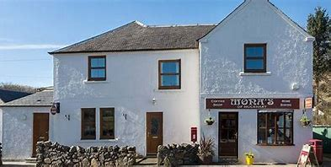  We look forward to welcoming you all here at Mona’s of Muckhart!
 | Japanese Garden at Cowden  Enjoy the historic Japanese Garden and woodland walks, which once connected Ella Christie’s home, Cowden Castle, to Sha Raku En (the place of pleasure and delight)  www.cowdengarden.com

Dating all the way back to 1908, The Japanese Garden was the vision of Ella Christie, owner of Cowden Estate, in which it sits. Ella was a great traveller and had a dream of building a Japanese Garden on her estate after travelling to the Far East and experiencing the beauty of these gardens for herself. After opening to the public in 2018, the Japanese Garden now operates as a charity, welcoming visitors from near and far to enjoy its peace and tranquillity and hear about Ella's story. As well as the formal garden, visitors can enjoy delicious lunches in the tearoom and explore woodland walks where a playpark and other kid’s activities can be found. Regular workshops and events are available, promoting Japanese arts and crafts, as well as an education programme offering school groups a fun and unique learning space.
For information about opening times and prices please visit www.cowdengarden.com

MUCKHART PRIMARY SCHOOL
Muckhart Primary is a small rural school with a current roll of 39. The current school was built in 1845 and is situated at the centre of the parish; this explains why the school is not in the centre of the village. The school is situated on the road to Muckhart Golf Club approximately half a mile from the centre of the village. Over the years the school has been modernised and new bits added on. We have extensive outdoor areas which we regularly use for teaching. We have strong community links and use the village and surrounding areas regularly to develop learning.

The school has a friendly and welcoming feel and a positive ethos. We work together for the benefit of all as one “Muckhart family”. Children are confident and happy in their learning.
The school handbook is available on its website:
Information for Parents and Carers | (glowscotland.org.uk)
Headteacher: Ms Lesley McGlinchie
muckhart@edu.clacks.gov.uk 01259 452356

Chairperson of the Parent Council: Jayne Price jayneylprice@me.com
LOCAL COMMUNITY REPRESENTATIVES

Community council representatives as above.

Local Political representatives
Clackmannan Local Councillors:
Denis Coyne (Conservative) Tel: 01259 452250/07854 376253
Email: dcoyne@clacks.gov.uk
Kathleen Martin (Labour) Tel: 01259 452250 / 07854 376253
Email: kmartin@clacks.gov.uk
Scott Harrison (SNP) Tel: 01259 452253 / 07811 069 456
Email: sharrison@clacks.gov.uk

Local MSP: Keith Brown (SNP), Clackmannanshire and Dunblane Constituency Tel: 01259 219333 Email: Keith.Brown.msp@parliament.scot

MP: Graeme Downie (Labour) MP, Dunfermline and Dollar constituency, Tel: 07936 739687, Email: graeme.downie.mp@parliament.uk

Muckhart Parish Church: Locum Minister: Rev Phillip Hacking, Tel: 07985 625831
E: phil.hacking@gmail.com

COMMUNITY ACTIVITIES AND GROUPS

Muckhart has several local groups with various activities taking place at the Coronation Hall and Muckhart Church. These are listed below along with timetables for both venues.

MUCKHART & GLENDEVON AMENITY SOCIETY
This is a local group which organises and helps with a variety of events from jazz BBQs to nature talks, Burns suppers, advent windows etc. Information on events can be found on the community website www.muckhart.org.uk or our committee deliver leaflets to each home and send emails to those on our list. Please contact us to join our list.
The society was set up with the following aims:
- To stimulate public interest in the care for the beauty, history and character of the area
- To develop and foster community spirit in Muckhart, Glendevon & surrounding area
- To encourage the preservation, development, and improvement of features of general public amenity or historic interest
- To encourage appropriate planning in Muckhart, Glendevon and the surrounding area
- To pursue these ends by means of meetings, exhibitions, lectures, social events and to promote schemes of a charitable nature.

MUCKHART PARISH CHURCH ACTIVITIES
MONDAY | TUESDAY | WEDNESDAY
MUCKHART MEANDERS  Walking group, all ages welcome, and polite dogs.  2 CHOICES  - 9.30 am walk - 2hrs approx. Meets at Coronation Hall.  - 9.45 am walk - 1hr approx. Meets outside Monas.  Both rounded off with a chat and refreshments at a local venue! |   KNITTING & NATTERING GROUP  MEETS 11-12 AM  This is open to anyone to come along to. If you don’t knit but do another craft, please bring this with you.  MAH-JONG GROUP  1.00 – 2.00 PM  Learning together as we go! |   BABY & TODDLER GROUP  9 – 11 AM  Annual Events  Summer (Teddy Bears Picnic)  Winter (Christmas Party)  ART CLUB  MEETS 2 – 4 PM  All ages abilities welcome!
TTHURSDAY | SUNDAY | NEW
SINGING GROUP .  9.45 AM DURING TERM TIME  Fun and informal  No experience needed – just  Willing to give it a go! | MORNING SERVICE 9.30AM  Doors open at 9.00am tea and coffee served.    From 9.30am - 10.30 am.  Primary School aged children. Craft, games, & fun. Snacks and refreshments served. | COMMUNITY CAFE AT CHURCH  First Monday of every month 10-30 - 12.30pm.  A chance for refreshments and a chat - bring a friend or make some new ones!
MUCKHART GOLF CLUB

With three 9-hole courses offering variety in both setting and challenge, we have something for everyone – from world-class golfers to social enthusiasts. The stunning Ochil hills provide an incomparable backdrop on every hole and all 3 courses are cleverly designed, bringing out the best of the local scenery as well as utilising the prevailing weather conditions to provide a fair test of golf. The restaurant and bar at the club is also very popular amongst the members and locals, with social events running throughout the year. We offer excellent value for money for 9 hole memberships or 18 hole memberships in various age categories, as well as our popular Get into Golf programme for those who are just taking up the game.
Please enquire at enquiries@muckhartgolf.com or come and visit us at our friendly and welcoming Clubhouse!

JUNIOR GOLF
Are you between the ages of 7-18? Fancy taking up golf? At Muckhart Golf Club we provide all junior golfers the opportunity to participate in an organised and inclusive golf programme that offers a fun and safe environment. We are committed to growing the game of golf through junior participation. For more information pop into the club or contact juniors@muckhartgolf.com.


GUIDING IN MUCKHART
We are fortunate that we have Guiding Sections for all age ranges in Muckhart, Rainbows, Brownies, Guides and Rangers. Our units are very busy and take part in all that guiding has to offer. We generally have spaces at all ages although currently we do have a waiting list for Rainbows. We meet in the Coronation Hall and are always happy to welcome adult volunteers. Guiding is great fun for all ages and stages.
If you are interested in becoming involved or want your daughter to join, please drop me an email and I will get back to you.
RAINBOWS | For girls aged between 4-7 meets on Tuesday evenings from 6-7pm
BROWNIES | For girls aged between 7-10 and meet on Tuesdays from 6 -7.30pm
GUIDES | For girls aged between 10-14 and meet on Mondays 7-9pm
RANGERS | For girls aged between 14-18 and meet on Mondays 7-9pm

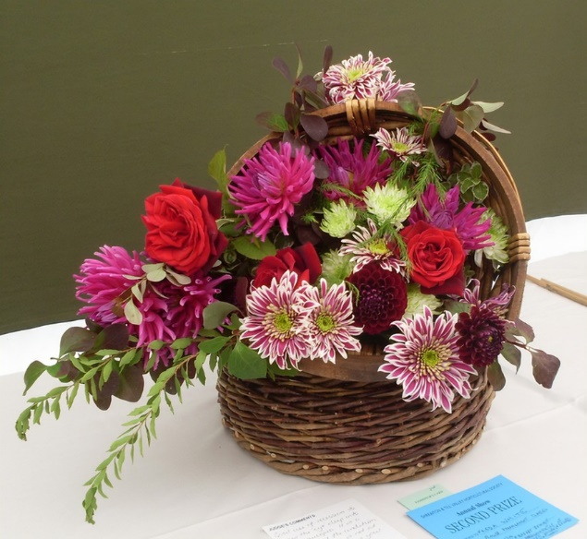
HORTICULTURAL SOCIETY
Every year on the 4th Saturday in August, the Muckhart and District Horticultural Society holds a village show in the Coronation Hall. Each household in the area gets a schedule earlier in the year and are invited to submit items for exhibitions into almost 240 classes. These range from photographs to knitted goods, baking to artwork and we especially welcome children’s work. The schedule is also available to view on the village website www.muckhart.org.uk. New members are very welcome on the organising committee. You don’t have to be an expert gardener, we are all amateurs, but we need new people with new ideas. If you don’t want to be on the committee (we only meet twice a year) we need help on the days leading up to the show to set up, serve teas etc.
ITALIAN LESSONS


My name is Maureen Sillence, and I hold advanced level book clubs on Mondays mornings in Muckhart Golf Club and for those with a basic understanding on Wednesday mornings. Both are from 10.30 – 12 and are free. I love speaking in Italian and visit Italy as often as I can. At least once a year I take some students with me to a language school in Siena or Lake Como. If you would like to find out more about these book clubs, please get in touch.
e-mail: maureen.italianclasses@gmail.com
Text: 07816 114157

MUCKHART MEANDERS
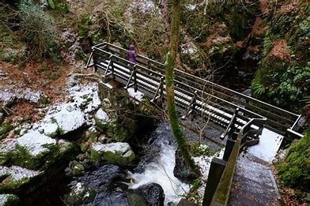
Come and join us! We meet at 9.30 am every Monday at the Coronation Hall, whatever the weather! Everyone is welcome and there is absolutely no charge and no commitment to come every week (unless you would like to). We walk around Muckhart, Dollar, Rumbling Bridge, Crook of Devon and Powmill (not all on the same day!). A shorter and longer walk is usually available.

We usually finish up with a coffee at Mona’s or the Golf Club as we like to support local businesses. If you feel that an hour and a half is too long, we have a second smaller group who also walk on a Monday but meet at 9.45 am outside Monas’s coffee shop. Both groups are open to ladies, gents, children, and well-behaved dogs!

NATURE PARK
Muckhart Nature Park started out as a Woodland Trust Scotland project. In 2006 the Trust approached Muckhart Community Council to form a committee who would involve the community with ideas both for starting up and maintaining our own park. The committee asked the Primary School and local groups to help create the park. A competition was held at the school to design a logo and groups of villagers helped to plant and seed the area. With funding from the Ochils Landscape Partnership and Heritage Lottery Fund, a pond was made, a forum created, and trees planted. The Nature Park committee needs new members to bring new ideas and fresh momentum to carry us into the next phase of maintenance and planting etc. Do you walk your dog in the park or use the path to the hills? If so, you could give something back to the village by joining us.

PLAY AND PERFORM WORKSHOPS

Our play and perform workshops are ideal for those new to or returning to drama. When we play, we are full of energy, alert and spontaneous. We look for playfulness in others and listen to creative impulses in ourselves. When playing we tend not to judge ourselves. If we are enjoying a game, we are fully involved in it. There is total belief and honesty. And lots of FUN!!
- We do not stop playing because we grow old
- We grow old because we stop playing
- Play awakens and gives full rein to the imagination, the root of creativity.

Group Games - Status Exercises - Improvisation - Playing with Rhythm - Playing with Text and more workshops to follow.
Comedy - Tragedy - Impro -Shakespeare - Panto - Indoor - Outdoor
What would you like? Let me know and …. LET’S DO IT!
Wear loose clothing and soft footwear so you can move easily.

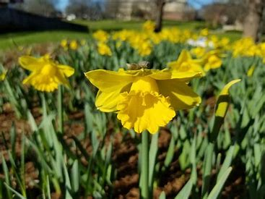
POT AND BLOOM
Pot and Bloom are a group of 4, and a subgroup of the Muckhart Horticultural Society. Our aim is to care for, and replant, when necessary, the village planters.
We look for funding and donations to help with this and hope to increase the number of planters and other planting initiatives in Muckhart. We involve extra volunteers from within the village if you would like to join in to assist at planting time. Further to the Keep Scotland Beautiful Initiatives, Pot and Bloom have planted two new planters. We use peat free compost and aim to fill planters mainly with plants good for pollinators. We have also planted more daffodils along the verges following a successful application for Foundation Scotland Funding.

SCOTTISH WOMEN’S INSTITUTE

SCOTTISH WOMEN’S INSTITUTES is Scotland’s leading member-based organisation and welcomes every woman in Scotland to join us.
Created by forward-thinking women in 1917, the SWI now offers a unique and inclusive community, where all women can have fun and form friendships, campaign, learn and share skills, and socialise with other women.
From gaining life skills and developing arts and crafts techniques, to raising awareness of current affairs affecting women and helping inform government issues, the SWI is proud of its heritage and future vision.
YOU ARE WELCOME to join our local sessions in Muckhart Church every third Tuesday of the month between September to May at 19.00, we would love to see you. Join to learn how to make that perfect scone …. And a lot more too!
For much more information about the SWI visit our website: theswi.org.uk or facebook page SWI Muckhart.

YOGA
Yoga is a non-competitive discipline that means union between your mind, body and soul. It can be practised by all ages and all levels of fitness. The aim of our yoga classes is to provide you with a relaxing and enjoyable session that will support your overall health and wellbeing. Combining yoga postures with breathing tools you will be guided through a sequence which if practised regularly will strengthen & tone the body, improve flexibility, lower blood pressure and reduce stress.
SIMPLI YOGA
One of the main benefits of a balanced session is that it will give your whole nervous system a deep rest. The children's classes introduce yoga/meditation in fun ways with games and mindful movements suitable to their age. For more info e-mail: enquiries@simpliyoga.com
Web Site: www.simpliyoga.com

The Contented Yogini also offer classes on Tuesday and Friday mornings at the hall.
For more info email: thecontentedyogini@gmail.com

GETTING ABOUT

Being situated in central Scotland, Muckhart is not far from Kinross which is a major bus hub with frequent bus links to Edinburgh and other destinations. The nearest railway station is in Alloa which has a regular service to Glasgow as well as various bus services.
There is currently no scheduled bus service in Muckhart apart from school transport although Muckhart Community Council are keen to improve transport in the area.

Glenfarg Community Transport Group Digital Demand Responsive Transport (DDRT) 203 pilot
The DDRT 203 pilot has been extended for a further 3 months and is now available from 0900 to 1700 on Mondays, Wednesdays and Fridays.
You can book your journey using the Ride Pingo app (preferred method) or by phoning GCTG's booking office on 0845 605 5955. Journeys are priced per mile, at a similar rate to local bus fares. All Scottish concession cards can be used for DDRT journeys. Cash, card and phone payments are also accepted.
The DDRT service connects with the hourly 23 service to Dollar and Tillycoultry, and also to Kinross. This is a developing service so please check GCTG's website for updates. If funding is obtained and the pilot proves successful, it is hoped that the service will run 6 days a week from 2026.
The full 23 timetable can be found at The 55 & 23 Public Bus Route Timetable - Glenfarg Community Transport. Please contact Marion at sec.muckhartcc@gmail with any queries.

Muckhart and West Kinross-shire Demand Responsive Transport
The Muckhart and West Kinross-shire Demand Responsive Transport Service (DRT1) is an on-demand transport service operating in the Muckhart and West Kinross-shire area. DRT1 operates within a defined area and time period and does not follow a fixed route or timetable.
Muckhart and West Kinross-shire Demand Responsive Transport – Perth & Kinross Council (pkc.gov.uk)
Call:
Angela’s cars, Kinross, tel:07508126720

HOUSEHOLD WASTE/RECYCLING

Containers and Bins
Clackmannanshire Council supply the following waste containers to householders:
- A Blue bin collected four weekly for plastic, tins, cans, empty aerosols and clean aluminium foil
- A Grey bin collected four weekly for clean, dry and flat paper and cardboard
- A Grey caddy collected weekly for all types of food
- A Green bin for material that currently cannot be recycled. This is collected every four weeks, unless your property has a special collection arrangement
- A Brown bin collected seasonally every three weeks for garden material. This service requires purchase of a permit.

Collection days are currently as follows:
Blue, Green and Grey bins – Tuesday, Food Caddy – Wednesday, Brown bin – Thursday
Recycling centres are located in Alloa and Kinross. Further details can be found at: Environment | Clackmannanshire Council (clacks.gov.uk). Glass recycling is located outside the Coronation Hall.
LOCAL AMENITIES
Food stores and services
Mona’s sell gifts and some staples but the nearest bigger shops are in Dollar, which also has the nearest hairdresser and a Co -op food store and delicatessen. The nearest large supermarket is Sainsbury’s in Kinross and Alloa also has a number of large supermarkets.
There are two fish vans – which come on a Tuesday and Wednesday. The Tuesday one ( A J Imrie ) starts at Cairns place around 7.50 am and goes down Drumburn Rd.
There is also a bread co-operative initiative with Wild Hearth Bakery based in Comrie. This enables great bread and pastries to be supplied to Muckhart residents without a delivery charge and at a reduced individual minimum order value. A delivery is made to a central point outside the Coronation Hall every Tuesday. More information can be found here: Invitation-to-join-a-Wild-Hearth-Bakery-community-bread-cooperative.pdf (muckhart.org.uk)
Other companies including dairy, butcher and vegetable suppliers also deliver to private Muckhart residences.
Petrol stations
The nearest petrol station is in Crook of Devon. Other stations are located in Kinross and Menstrie.
Post Office
The nearest Post Office is in Dollar however a mobile post office van visits Muckhart on Monday and Wednesday afternoons (3 – 4 pm). It is located outside the Coronation Hall.
Libraries
Council libraries can be found in Alloa and other Clackmannanshire locations and in Kinross. Muckhart also has its own community book exchange.
Community Book Exchange
This is located at the back of the Coronation Hall, next to the lane running from the main road to School Rd. Housed in our brand-new wooden cupboard, courtesy of a microgrant from Muckhart Community Council and the carpentry skills of our very own Tim Barrett. Please feel to open the doors and have a browse. Bring your unwanted books and select some new ones to read! Please ensure the doors are kept closed to keep the weather out and the books dry!

LOCAL SERVICES
Council services
Clackmannanshire Council has its own website with links to services at Clackmannanshire Council Online (clacks.gov.uk). Contact tel: 01259 450000.
Health Centre
Dollar Health Centre provides General Practice and Primary Healthcare services for Muckhart and area residents. dollarhealthcentre.org.uk Contact tel: 01259 742120.
Hospital services
The main hospital is Forth Valley Royal Hospital in Larbert and includes A and E services. NHS Forth Valley – Forth Valley Royal Hospital Contact: 01324 566000.
There is also a Minor Injuries Unit in Stirling, located at Stirling Health & Care Village, Livilands Gate, Stirling, FK8 2AU. This provides treatment for a wide range of common injuries such as sprains, cuts (including those requiring stitches), burns and suspected broken bones (open daily 9am – 9pm). NHS Forth Valley – Minor Injuries Unit. You should now call NHS 24 on 111, day or night before attending the Minor Injuries Unit.
Community Defibrillators
There are 2 Community Defibrillators available for use by anyone. Instructions on using them are given on the device and are very clear.
In the event of a suspected Cardiac Arrest stay with the patient.
- Phone emergency services (ambulance) by calling 999, (keep your address and phone number handy) and describe the situation
- Arrange for collection of the defibrillator at the Coronation Hall

One defibrillator is located at the Coronation Hall, School Rd, Muckhart FK14 7JF in the car park within the yellow cabinet mounted on the wall adjacent to the fire exit. The other one is located in the telephone box on the main road near the entrance to Meadowside Crescent. If you need any help a member of the Muckhart defibrillator team can be contacted for additional support.
- Ben Price 07793 525166
- Neil Duthie 07989 408382
- Sheena and John Anderson 01259-781391

If you remove the defibrillator from its location, remember to hang the sign (DEFIBRILLATOR HAS BEEN COLLECTED) on the outside of the cabinet door.
Please contact Ben Price if the defibrillator has been removed and/or used.
Dentists/Opticians/Vetinary services
A number of providers are available within Clackmannanshire, Stirling and Kinross.

Police Services
Our local police services can be contacted by calling 101 or by e-mail at:
barry.reiter@scotland.pnn.police.uk
barry.ritchie@scotland.pnn.police.uk

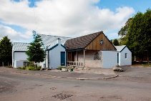
WHAT’S ON AT THE CORONATION HALL

MONDAY | 19.00-21.00  19.00-21.00 | GUIDES  RANGERS
TUESDAY | MORNING  9.30 – 11.00  15.30 –16.30  18.00 - 19.30 | WILD HEARTH (BREAD CO-OPERATIVE)  YOGA  CHILDREN’S YOGA  RAINBOWS & BROWNIES
WEDNESDAY | 09.30 -12.30  17.30-18.30  19.00  19.30 | PILATES  YOGA  FAMILY BADMINTON EXCEPT WHEN  MUCKHART COMMUNITY COUNCIL (Certain Dates only)
THURSDAY | 09.30-10.30  16.15-17.15  18.00-19.15 | BARRE FITNESS  CHILDRENS YOGA  GENTLE YOGA
FRIDAY | 9.30 – 11.00  17.30 – 19.00 | YOGA FLOWS  ALBA PERFORMING ARTS – KIDS DANCE
SATURDAY | 09.30-12.45 | INSPIRE THEATRE WORKSHOPS (Certain Dates Only)
SUNDAY | AVAILABLE ALL DAY

Other regular users include the Coronation Hall Committee, Community Council, Horticultural Society, Nature Park Committee. However, the hall is available for hire if you are interested.

All hall bookings are visible on our online calendar, bookings and enquiries can also be made online via the Muckhart Community Council website muckhart.org.uk.
Short cut web address for booking the hall - muckhart.org.uk/local-groups/coronation-hall/

CONTACT LIST
GROUP | CONTACT | TEL NO | E-MAIL
MCC Chair | Gillian Thompson | 07713 155607 | Gillyj232@gmail.com
MCC Secretary | Marion Riddell | 07778 555229 | sec.muckhartcc@gmail.com
Muckhart Church - Sessions Clerk | Greer Conroy | 07931 677795 | greer.conroy@outlook.com
Muckhart Church - Sunday School | Susan Duthie | 07766 668039 | sduthieyetts@gmail.com
Muckhart Primary School | Lesley McGlinchie | 01259 781356 | muckhart@edu.clacks.gov.uk
Muckhart Primary Parent Council | Jayne Price |  | jayneylprice@me.com
Defibrillator | Ben Price | 07793 525166
Muckhart Coronation Hall | Alison Peden | 07766 780538 | ajpeden.watson@googlemail.com
Muckhart and Glendevon Amenity Society | Cindy OnkenGlimm | 07341 979715 | conkenglimm@gmail.com
Muckhart Baby and Toddler Group | Fran McNicoll | 077080 55515 | fmcnicoll2014@hotmail.co.uk
Muckhart Brownies | Morgan Erskine | 07979 993366 | merskine@girlguidingtayandochils.org
Muckhart Guides | Bev Dunn |  | bev1dunn@gmail.com
Muckhart Rainbows | Bev Dunn |  | bev1dunn@gmail.com
Muckhart SWI | Diane McMillan | 07916 127592 | dimcmillan@btinternet.com
Muckhart Horticultural Society | Margot McKerrell | 07753 131294 | margotmckerrell@btinternet.com
Muckhart Knitting and Nattering | Greer Conroy | 07931 677795 | greer.conroy@  outlook.com
Muckhart Nature Park | Tim Turner | 07771 987474 | info@oldstones.co.uk
Muckhart Pot and Bloom | Hilary Craig | 07594 603878 | hilcraig@yahoo.co.uk
Muckhart Singers | Sheena Anderson |  | sheena.c.anderson@btinternet.com
Simpli Yoga Adults / Kids | Sarah Smart | 07466 360152 | sarahjsmart@hotmail.com
The Contented Yogini | Sarah Cunningham |  | thecontentedyogini@gmail.com
Barre | Holly McFarlane |  | hello@barrewithholly.com
Japanese Garden Cowden |  | 07876 117703 | info@cowdengarden.com
The Muckhart Inn | Derrick Graham | 01259 781324
Mona's | Amy Gullen | 01259 781322 | amy.monasofmuckhart@outlook.com
Muckhart Golf Club | Secretary | 01259 781423 | enquiries@muckhartgolf.com

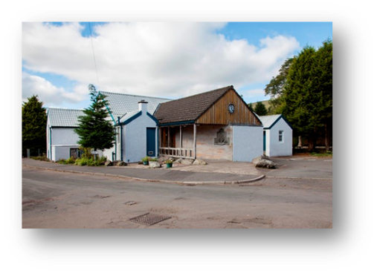
FRIENDS OF CORONATION HALL - 100 CLUB

Dear Friend
I am writing to let you know about our very own lottery called the 100 Club. Every month someone wins £100 for the small monthly sum of £4 or £48 annually. All the profits go towards maintaining and improving our wonderful Coronation Hall. If you would like to join in, please follow the instructions below and return it by emailto:Coronationhallmuckhart@gmail.com or pop it through the letter box of the Coronation Hall. The form is also available at 100-Club-Membership-Application-Form-Input-allowed.pdf (muckhart.org.uk)
Thank you.

Muckhart Hall Committee.

Our bank details are: Muckhart Coronation Hall No. 2 account, Virgin Bank, sort code: 82-62-08, account number 10397519.
Name ……………………………………………………………………………………………….
Address …………………………………………………………………………………………….
e-mail address ………………………………………………………………………………….
METHOD OF PAYMENT – If you are setting up a standing order, please give your surname as a reference.
a) Standing order monthly (£4)
b) Standing order annually (£48)
c) Cheque annually (£48)
Please give your bank details so that we can pay the winners by bank transfer:

Bank name …………………………………………………
Sort code ……………………………… Account number ……………………………

