# EDF Renewables Burnfoot Hill Wind Farm Community Fund

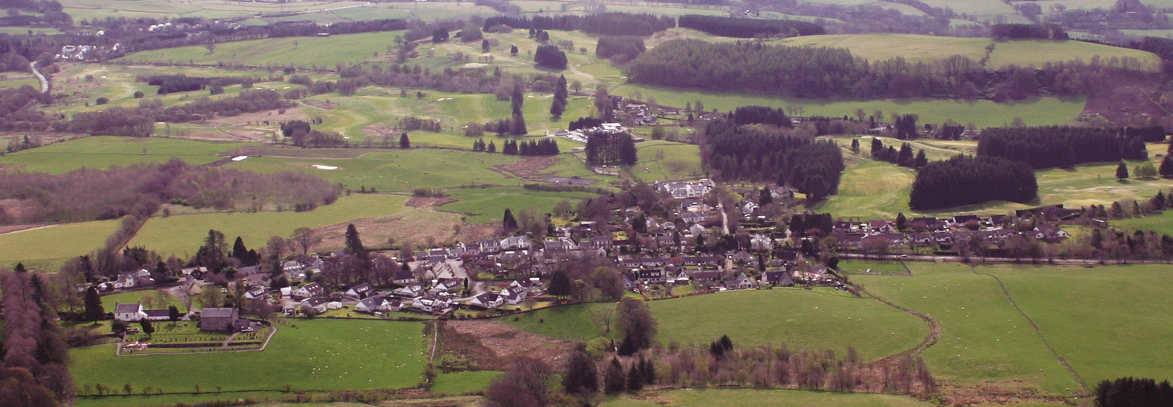

**Muckhart Community Council**

**Microgrant Application Form 2025/26**

**(Up to £250 for an individual or £500 for a group)**

1. **Contact Details**

Name of group or individual applying:

Main contact:

Address:

Postcode:

E-mail: Telephone (main):

1. **About you or your organisation**
2. Are you a small, un-constituted group?
3. Are you an individual?
4. Are you a Constituted Group?
5. **Details of Microgrant Requested**

|  |
| --- |
| Tell us about you or your organisation (aims, purposes etc) |
|  |

|  |
| --- |
| * Describe the activities that the microgrant will fund * When will these activities take place? |
|  |

|  |
| --- |
| * Tell us who and how many will benefit from the microgrant funding * For each beneficiary identified what difference or change will the microgrant make |
|  |

|  |
| --- |
| * How many volunteers are involved in delivering your project * What are their roles? |
|  |

|  |
| --- |
| What do you think the lasting changes the microgrant funding will make to you or the community |
|  |

1. **How much are you requesting?**

What will the micro-grant be used to pay for? (Please provide a cost breakdown and quotes where applicable)

|  |  |
| --- | --- |
| **Description** | **Cost** |
|  |  |
|  |  |
|  |  |
|  |  |
|  |  |
|  | **Total:** |

**Declaration:** I certify that the information contained in this application is correct and that I am authorised to make the application on behalf of the above group/ individual.

Name (please print):

Signature: Date:

Please send your completed applications to: [​sec.muckhartcc@gmail.com](mailto:sec.muckhartcc@gmail.com)

**‘*Funded by Foundation Scotland from the EDF Burnfoot Hill Community Fund’***