# EDF Renewables Burnfoot Hill Wind Farm Community Fund

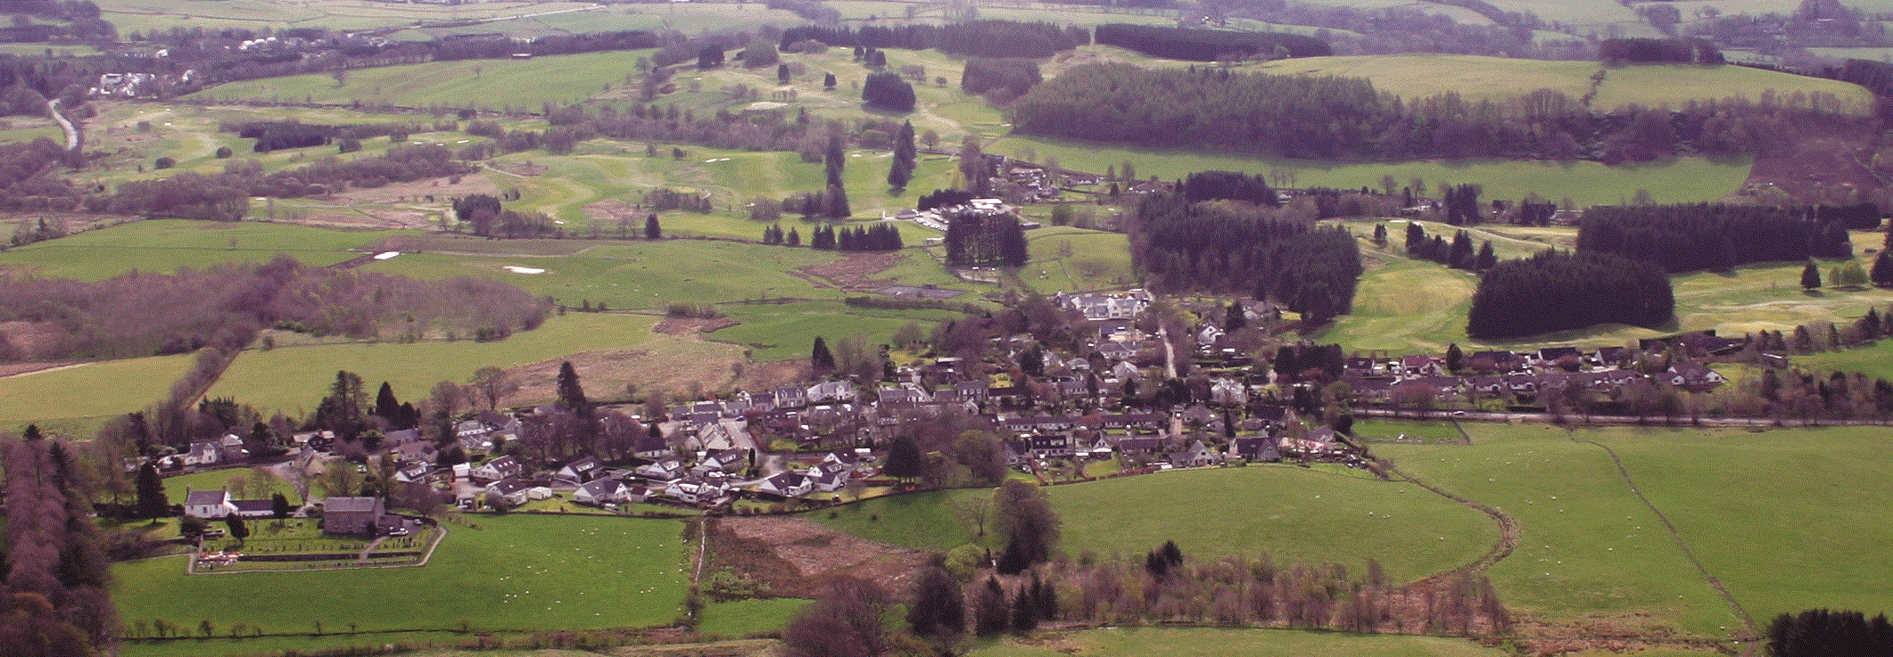

**Muckhart Community Council**

**Event Fund Application Form 2025/26**

**(Up to £500 for a group)**

1. **Contact Details**

Name of group applying:

Main contact:

Address:

Postcode:

E-mail: Telephone (main):

1. **About your organisation**
2. Are you a small, un-constituted group?
3. Are you a Constituted Group?
4. **Details of Event Fund Requested**

|  |
| --- |
| Tell us about your organisation (aims, purposes etc) |
|  |

|  |
| --- |
| * Describe the Community Event that the Event Fund will fund * When will these activities take place? |
|  |

|  |
| --- |
| * How will your Community Event bring the Community Together? |
|  |

|  |
| --- |
| * Tell us who and how many will benefit from the funding |
|  |

|  |
| --- |
| * How many volunteers are involved in delivering your project * What are their roles? |
|  |

|  |
| --- |
| What do you think the lasting changes Event funding will make the community |
|  |

1. **How much are you requesting?**

What will the micro-grant be used to pay for? (Please provide a cost breakdown and quotes where applicable)

|  |  |
| --- | --- |
| **Description** | **Cost** |
|  |  |
|  |  |
|  |  |
|  |  |
|  |  |
|  | **Total:** |

**By signing the declaration below I confirm that:**

* I have permission of the land owner, if required.
* I have or will have adequate insurance.
* I have carried out risk assessments and will have an appropriate event plan in place, if required.
* If required i will have appropriate licenses in place by the time of the event.
* I have reviewed Clackmannanshire Council’s guidance on running a public event [Planning a public event (clacks.gov.uk)](https://www.clacks.gov.uk/council/planningpublicevent/)

**Declaration:** I certify that the information contained in this application is correct and that I am authorised to make the application on behalf of the above group/ individual.

Name (please print):

Signature: Date:

Please send your completed applications to: [sec.muckhartcc@gmail.com](mailto:sec.muckhartcc@gmail.com)

**‘*Funded by Foundation Scotland from the EDF Burnfoot Hill Community Fund’***