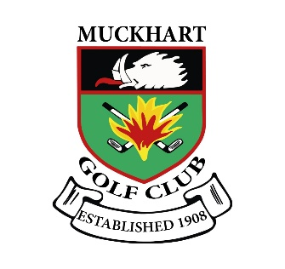 | MUCKHART GOLF CLUB  Funeral Menu

Option 1

Selection of sandwiches, sausage rolls, assorted biscuits, tea & coffee.

£4.50

Option 2

Selection of Sandwiches, Sausage rolls, mini quiche assortment, assorted biscuits, tea & coffee.

£5.00

Option 3

Homemade lentil soup, assorted sandwiches, assorted biscuits, tea & coffee.

£5.50

Option 4

Homemade lentil soup, assorted filled rolls, sausage rolls, tea & coffee.

£6.50

HOT BUFFETS

Chicken curry, Chilli, Beef Curry, Macaroni Cheese, Stovies, Pasta Bake, Beef Stew

£7.00 Per Person

(ALL BUFFETS REQUIRE PAYMENT 24HRS BEFORE THE EVENT)

(A Supplement of £2.50 pp For Special Dietary Requests, Vegan Dairy Free Etc)

