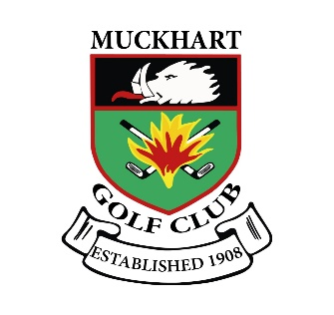 | MUCKHART GOLF CLUB  FUNCTIONS BUFFET MENU

Buffet Option 1

Selection of sandwiches, sausage rolls, pizza, crisps, nuts

£4.00

Buffet Option 2

Selection of Sandwiches, Sausage rolls, Chicken Goujons, Mini Pork Pies, Chinese Mini Selection, Pizza selection, Crisps & Nut Selection.

£5.00

Buffet Option 3

Selection of filled rolls, Sausage rolls, Savory Mini Quiche, Crispy Chicken, Pizza
Selection, Mixed Indian selection, Chicken Wings, Crisps, Nuts.

£5.75

Buffet Option 4

Selection of Filled Rolls, Mini Pork Pies, Assorted Chicken Drumsticks, Mixed Pizza Sausage rolls, Savory Mini Quiche, Oriental selection & Dips, Crispy Chicken, Crisp & Nut Selection.

£6.75

HOT BUFFETS

Chicken curry, Chilli, Beef Curry, Macaroni Cheese, Stovies, Pasta Bake, Beef Stew ETC
(Any other Request Please Ask)
£7.50 Per Person

(ALL BUFFETS REQUIRE PAYMENT 24HRS BEFORE THE EVENT)

(A Supplement of £3.00 pp For Special Dietary Requests, Vegan Dairy Free Etc)

